**i) LED BLINKING USING DAQ:**

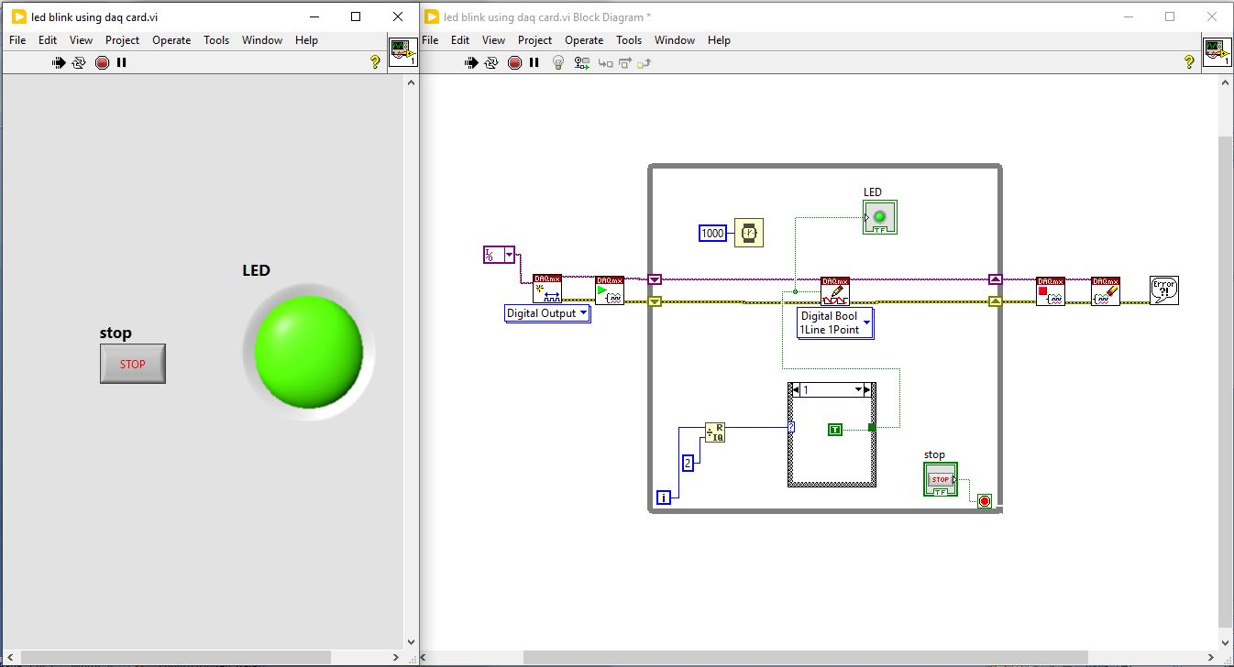

**ii) INTERFACING LM35:**

